**MINI-PROJECT REPORT**

**ON**

Online Bus Ticket Reservation System



REPORT SUBMITTED

TO

VISHWAKARMA INSTITUTE OF INFORMATION TECHNOLOGY, PUNE

FOR THE Mini-Project OF JAVA

IN

**INFORMATION TECHNOLOGY DEPARTMENT**

BY

**Name of the student –ANKUSH PATIL-21810232/232043**

**Name of the student –ABHISHEK SALAPE-21810258/232055**

**Name of the student –TEJAS SARNAIK-21810308/232056**

**Name of the student –MANASI PURKAR-21810414/232050**

**Class:SY-IT Division: B Batch:B2**

**Batch Teacher**

**Mrs.Suvarna Pawar**

## Mini Project 3) Server side Programming

## Server side mini-project using Servlets and JDBC Connectivity with MySQL Database

## Online Bus Ticket Reservation System

## Abstract

This research study discusses the detail overview in

developing a client server based application using socket

programming in a distributed computing environment. The

researchers developed a client-server based application called

OpTel Billing System (OBS) using Java NetBeans and TCP

datagram to demonstrate the concepts of socket programming

and its communication in a distributed computing. Interface

design, socket programming style, java classes, and exceptions

are also considered in the development stage. The

communications between client server application processes

using socket mechanism were mainly analyzed. The main

objective of this research study is to demonstrate the principles

and concepts behind socket programming as well as the libraries

available in Java. In conclusion, socket programming is one of

the best method in distributed computing that can improve

system’s performance

This research study discusses the detail overview in

developing a client server based application using socket

programming in a distributed computing environment. The

researchers developed a client-server based application called

OpTel Billing System (OBS) using Java NetBeans and TCP

datagram to demonstrate the concepts of socket programming

and its communication in a distributed computing. Interface

design, socket programming style, java classes, and exceptions

are also considered in the development stage. The

communications between client server application processes

using socket mechanism were mainly analyzed. The main

objective of this research study is to demonstrate the principles

and concepts behind socket programming as well as the libraries

available in Java. In conclusion, socket programming is one of

the best method in distributed computing that can improve

system’s performance

This research study discusses the detail overview in

developing a client server based application using socket

programming in a distributed computing environment. The

researchers developed a client-server based application called

OpTel Billing System (OBS) using Java NetBeans and TCP

datagram to demonstrate the concepts of socket programming

and its communication in a distributed computing. Interface

design, socket programming style, java classes, and exceptions

are also considered in the development stage. The

communications between client server application processes

using socket mechanism were mainly analyzed. The main

objective of this research study is to demonstrate the principles

and concepts behind socket programming as well as the libraries

available in Java. In conclusion, socket programming is one of

the best method in distributed computing that can improve

system’s performance

A very simple cross platform client server Bus Reservation web-application has been implemented in Java. We observed the working of the Bus reservation system and after going through it, we get to know that there are many operations, which they have to do manually. It takes a lot of time and causing many errors while data entry. Due to this, sometimes a lot of problems occur and they were facing many disputes with customers. To solve the above problem, and further maintaining records of passenger details, seat availability, price per seat, bill generation and other things, we are offering this proposal of computerized reservation system.

## Theory

* Java JDBC

JDBC stands for Java Database Connectivity. JDBC is a Java API to connect and execute the query with the database. It is a part of JavaSE (Java Standard Edition). JDBC API uses JDBC drivers to connect with the database. There are four types of JDBC drivers:

* JDBC-ODBC Bridge Driver,
* Native Driver,
* Network Protocol Driver, and
* Thin Driver

We can use JDBC API to access tabular data stored in any relational database. By the help of JDBC API, we can save, update, delete and fetch data from the database. It is like Open Database Connectivity (ODBC) provided by Microsoft.

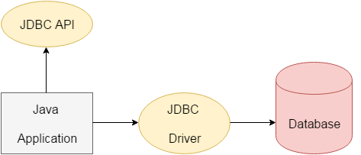

* What Is a Servlet?

A servlet is a Java programming language class used to extend the capabilities of servers that host applications accessed by means of a request-response programming model. Although servlets can respond to any type of request, they are commonly used to extend the applications hosted by web servers. For such applications, Java Servlet technology defines HTTP-specific servlet classes.

The javax.servlet and javax.servlet.http packages provide interfaces and classes for writing servlets. All servlets must implement the Servlet interface, which defines lifecycle methods. When implementing a generic service, you can use or extend the GenericServlet class provided with the Java Servlet API. The HttpServlet class provides methods, such as doGet and doPost, for handling HTTP-specific services.

* Configuring Eclipse as a Web Development IDE

The IDE is the most important aspect when developing with JavaScript. An IDE integrates the various tasks required to write web applications into a single interface. In reality, you could use any text editor to write HTML, CSS, JavaScript, and jQuery code. However, you will find it much more productive and easy to use a good IDE.

We chose Eclipse for this book because it is a great general IDE that is easy to configure and set up. You can use your own IDE if you would rather; however, this might be a good chance to try a different IDE if you are unfamiliar with Eclipse.

* Tomcat Server

Tomcat is an [application server](https://searchsqlserver.techtarget.com/definition/application-server) from the Apache Software Foundation that executes Java [servlet](https://whatis.techtarget.com/definition/servlet)s and renders Web pages that include [Java Server Page](https://www.theserverside.com/definition/Java-Server-Page-JSP) coding. Described as a "reference implementation" of the Java Servlet and the Java Server Page specifications, Tomcat is the result of an open collaboration of developers and is available from the [Apache](https://whatis.techtarget.com/definition/Apache) Web site in both binary and source versions. Tomcat can be used as either a standalone product with its own internal [Web server](https://whatis.techtarget.com/definition/Web-server) or together with other Web servers, including [Apache](https://whatis.techtarget.com/definition/Apache), Netscape Enterprise Server, Microsoft Internet Information Server ([IIS](https://searchwindowsserver.techtarget.com/definition/IIS)), and Microsoft [Personal Web Server](https://whatis.techtarget.com/definition/Personal-Web-Server-PWS). Tomcat requires a Java Runtime Enterprise Environment that conforms to JRE 1.1 or later.

#### SYSTEM OUTPUT :

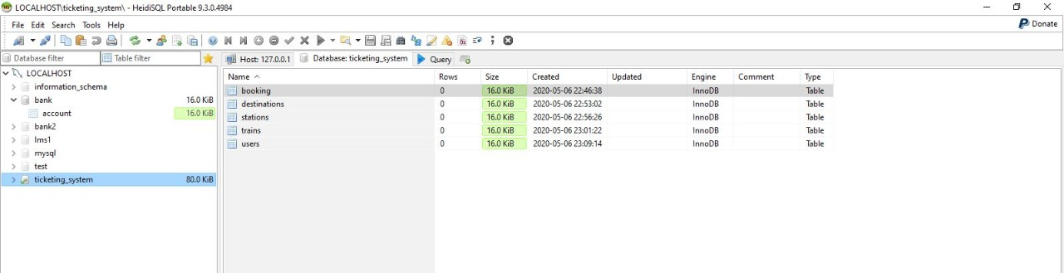

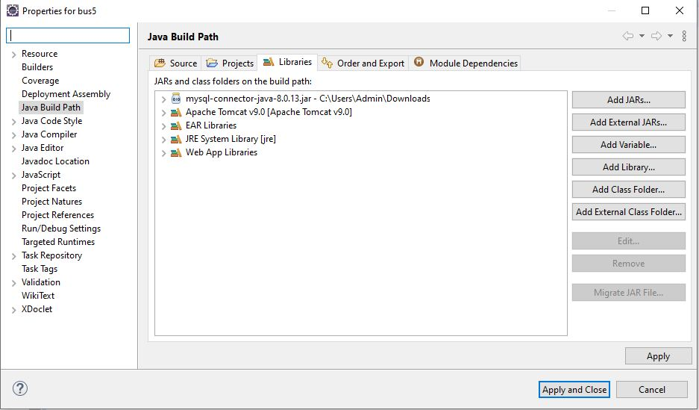

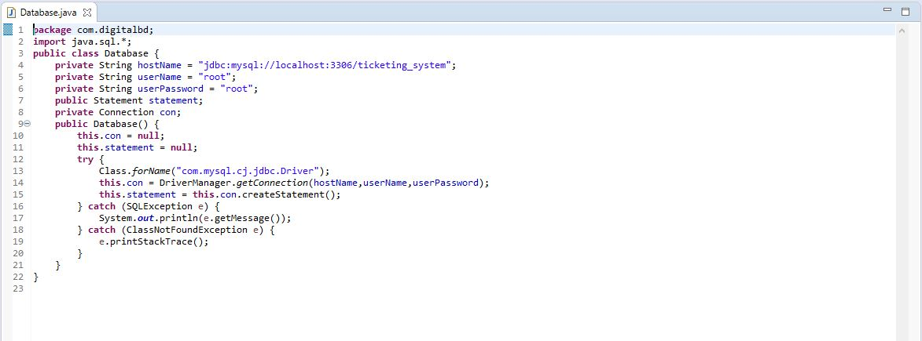

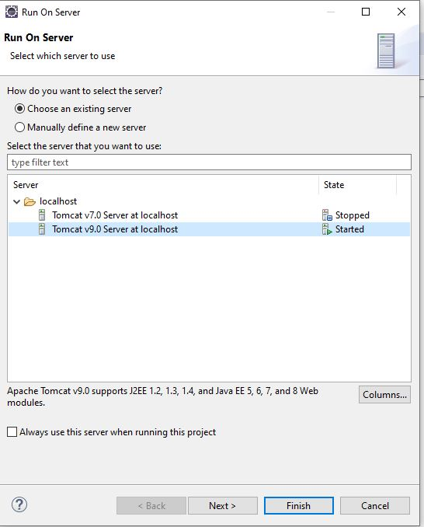

## **C:\Users\Acer\Downloads\WhatsApp Image 2020-05-08 at 12.17.57 PM.jpeg**

## **C:\Users\Acer\OneDrive\Desktop\2.jpg**

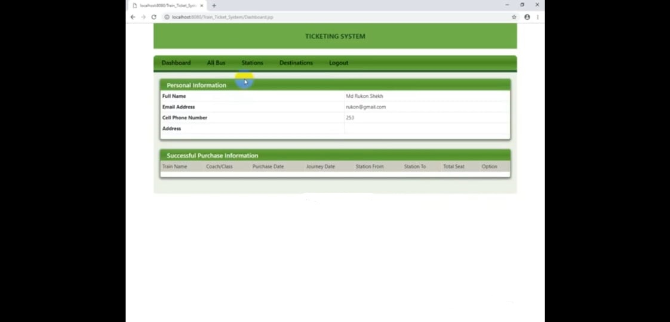

## **C:\Users\Acer\OneDrive\Desktop\4.jpg**

## **C:\Users\Acer\OneDrive\Desktop\5.jpg**

## **C:\Users\Acer\OneDrive\Desktop\6.jpg**

## **C:\Users\Acer\OneDrive\Desktop\7.jpg**

## **References:**

* Wikipedia, “Scripting language”
* <http://www.w3schools.com/js/js_objects.asp>
* <https://www.javatpoint.com/>

## **CONLUSION :**

* This study involved server-side programming with Java servlets to produce dynamic Web pages and Web database applications. As mentioned before, currently, CGI is the most commonly used method in this field. Java servlets are new, exciting fast growing technology in web programming.
* This study demonstrated that Java servlets can be used on-line testing/courseware programming. It utilized instant grading for student’s quizzes, eliminating human grading/corrections. The grades were stored in the database. This also simplifies the calculation of student’s average final course grades